
Tabletop Tag Game

© 2008 by Santo Ciaravino

http://scskwirl.webs.com

GAME INSTRUCTIONS

*

Welcome to the game of Tag 'em! In this game, you command five pawns as you play any game type you want, with as many players as you wish, and with maps you can create, in a creative approach to a fun action strategy game.

Equipment
To play this game, you will need to have:
- 5 Small-sized “pawns” (such as glass stones, coins, small figurines, etc.) per Player
  - 2 or more players can play, depending on the game board size.
- Two 6-sided dice
  - Both dice should be different colors to tell which player rolled what die.
- A “Tag 'em” game map
  - You can either print the pre-made map from the back of this document, or create your own however you want to. You can find more details on creating your own maps in the “Making Maps” section.
- Coins or Tokens (Optional; for Flag-Capturing game modes)

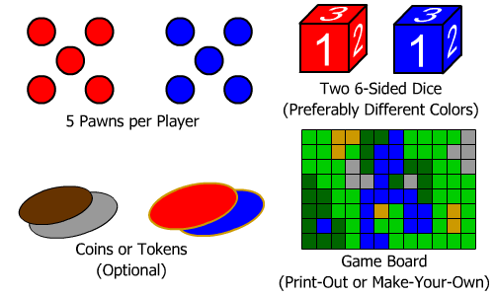

Setup
Before playing, you must have a game map, participating players ready to play, and a game objective to play to. Depending on the size of the map, you may want fewer or more players. For example, a map made on an 8.5”x11” Paper map might be good for 2 players, while much larger maps (like on oak-tag) can have as many as 4 or more players.

As well, depending on the map size, choose a number of “Points of Movement” each player can move their pawns on their turns, to accommodate the size of the map and moving around in it. If the map is very small, you may want to use fewer moves, while larger maps should allow for more moves. A good way to decide the amount is to go by increments of 5. Maps made on an 8.5”x11” Paper map could hold about 10 Points of Movement for two players, slightly larger maps can hold 15 Points of Movement, even larger maps can hold 20 Points of Movement, etc.
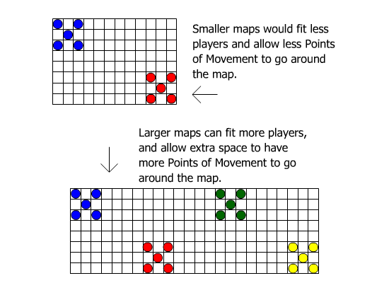
Finally, you will want to choose “Starting Points” on the map for each player's set of pawns to start on. You may want to place each Starting Point fairly apart from each other, and for any game with an objective such as “Capture-The-Flag”, you will want the objective to be fairly distant from the players' Starting Points. A suggestion to remember which point is your Starting Point is to put a coin or a mark on that spot.

When Starting Points are decided, each player takes their 5 pawns and places 1 pawn on the Starting Point, and the other 4 pawns go on the four tiles diagonal of the starting point, so the pawns form an X. If you are playing games where your pawns can respawn, you use your Starting Point to bring back your pieces, and if there is a pawn there already, continue the X formation to put the returned pawns.

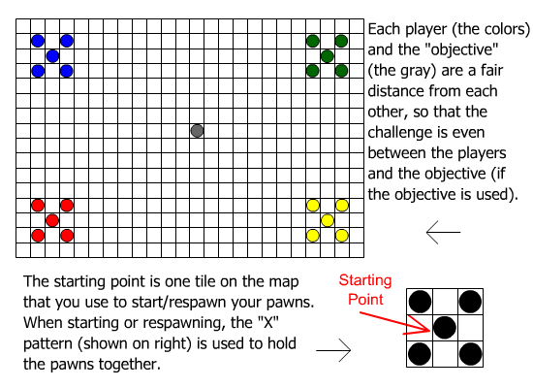

After everything is set up, the players decide the turn order, and the game can begin.

Initial Rules
All of the game modes follow the same set of rules when playing, and only differ by how to win. This section explains each part of the game that is common for any game mode.

Movement
On every player's turn, depending on the map, the player begins with a set amount of “Points of Movement” (PoM), that the player can move their pawns around the map, one space at a time in any way they wish.

For example, if the set PoM is 10, that means each player can move any of their pawns in 10 moves, not individually but altogether, so for 5 pawns, you can move each one with 2 moves to make up 10 points of moving your pawns.

When moving, you cannot go diagonal into another tile or into an already-occupied tile; only vertically or horizontally into empty tiles on the grid.

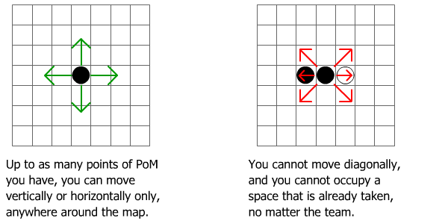

At any time in your turn, if you have PoM that you do not want to use, you may forfeit your turn to the next player.

When moving around the map, certain tiles have an effect on each pawn's movement. For example, the “Wade” tiles cost 2 PoM to move around in, and the “Garrison” tiles do not allow the pawn to continue for the rest of the turn once they are entered.

When moving between tiles, the one that gives the effects in movement is the one that the pawn is moving from. For example, if the pawn is moving from a “Path” tile (which is the normal plain tile) and into a “Wade” tile, it will cost 1 PoM, but going the other way will cost 2 PoM to get out from the “Wade” tile and into the “Path” tile again. There is more information on tile types later in this section.

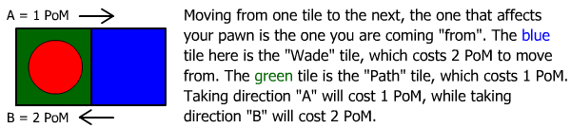
Points of Movement are also used when initiating an attack move (again not diagonal, only horizontal or vertical). It always costs only 1 PoM to make an attack, no matter what tile you are on. When a pawn is adjacent to an opponent's pawn, the current player can decided to initiate an attack. There is more information on attacking later in this section.

Tile Types
On any map, there are 5 different types of “tiles”, which are any of the colored squares on the grid. Each has a different function:
- Path – Path tiles are normal and do not have any effects. They cost 1 PoM to move through.
  - Example Environment: Road, Grass, Dirt
- Cover – Cover tiles are just like Path tiles when moving through them, and cost only 1 PoM to move through. But when a player's pawn attacks a pawn that is inside a Cover tile, the attacker's pawn will lose -1 on the die roll (as it is harder to attack the pawn in cover), regardless of what tile the attacking pawn is in.
  - If the attacker is on a Garrison tile, there is no bonus or penalty. The -1 from the defender being in the Cover tile and the +1 from being in the Garrison tile cancel each other out.
  - Example Environment: Forest, Foxholes, Sandbags, Ruins
- Wade – Wade tiles are just like Path tiles, but cost 2 PoM to move through, as if slowly wading through the thick of muckier, unstable, or deep areas.
  - Example Environment: Water, Swamp, Rubble
- Garrison – Garrison tiles are spots your pawns can sit in for an extra advantage to beat nearby opponents, like a fortification. Once the pawn enters a Garrison tile, they cannot move for the rest of the player's turn and must wait for the next turn to move out of it, but if the pawn attacks or gets attacked as long as it is in a Garrison tile, that garrisoned pawn gets a +1 on all die rolls, whether defending or attacking.
  - If both pawns in an attack move are in a Garrison tile, there is no need to use a +1 on their die rolls, since even without the bonus they would still be the same number apart. As well, the Garrison's bonus only counts on the two pawns that are attacking/defending, not from the surrounding pawns of a Horde Bonus who may or may not also be in Garrison tiles.
  - Example Environment: Pillbox, Hill, Building
- Block – Block tiles are spots that cannot be entered, like obstacles or heavy barricades.
  - Example Environment: Boulder, Wall

If you are using a custom map, you can include different tiles with different effects to play with.

Attacks
When a current player's pawn is next to an opponent's pawn, that player can choose to either move on, or start an attack roll with that opponent's pawn. If the player decides to start the attack, both the player and the defending opponent take one of the two dice, but they do not roll yet. First, the players must look at the factors that may change the die roll, including:
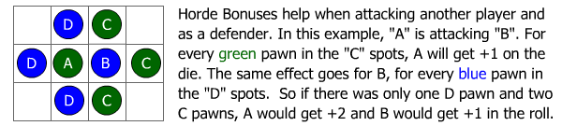
- Horde Bonus
If there are more of the current player's pawns surrounding the opponent's pawns from the other three open spots horizontally and vertically, the attacking player gets a “Horde Bonus”, which is +1 per extra surrounding pawn on the opponent, on the attacker's die. This same effect also works for the defender, if the defender has any surrounding pawns on the attacker's pawn.
The only thing that Horde Bonuses don't have much effect over is the tile each surrounding pawn is on. For example, if one of the assisting pawns is on a Garrison tile, the extra +1 on the Garrison tile does not count, and the attacking/defending pawn will only get +1 for the assisting pawn instead of +2 for both the assisting pawn and the assisting pawn being inside a Garrison tile.
As well, even if the defender is on a Cover tile, the assisting pawns that are helping the attacking pawn do not suffer the -1 penalty to cancel out the +1 they give.
- Tile Types
Some tile types may affect the outcome of a roll, such as Cover and Garrison tiles.
  - Garrison tiles give the occupant a +1 on the die roll when attacking or defending.
  - When a defender is in a Cover tile, the attacker suffers a -1 on the die roll.

After everything is checked and the bonuses/penalties are put together, the roll may begin. After rolling the die, tally up the bonuses/penalties that go for the players' die rolls and see who has the highest overall score. Whoever is the losing player may either lose the pawn permanently or have it sent back to the Starting Point, depending on the game type. The winning player does not immediately move into the old tile the opponent's pawn had during the attack.

If for any reason your pawn is lost while on your Starting Point and it must be respawned, but either the opponent(s) are next to the Starting Point or the other spaces surrounding the Starting Point are taken, choose a tile about 2 or more spaces away from your Starting Point and put the pawn there. This is to avoid respawning in the very same place the pawn was lost in, which would make winning certain games an impossible task.

Game Types
Using this game's initial rules, you can always create your own objectives to play. Here are 3 sample game types you can play.

Elimination
Each team must battle and eliminate each other's pawns. The last remaining team wins the game.

The only way to play this game is to go up to your opponents and start attack moves on them and try to survive if the opponents attack you. Your best bet is to use Horde Bonuses effectively.

When a player's pawn is defeated in an attack move, the pawn is eliminated from play.

Capture-The-Flag
There is one “flag” on the whole map. The winning player is the one that brings the flag back to their Starting Point, but must survive the onslaught of the other players trying to get that same flag for the same goal.

To play this game, you need one coin or similar item to represent the flag. Place it on the map fairly distant from the Starting Points of each player. Every player must try to land on this flag and bring it back to their Starting Point to win. The flag moves with the pawn that landed on the flag, unless the pawn is defeated in an attack move, in which case the flag is then left up for grabs. As with attack moves, pawns do not enter the opponent's old space unless they spend the 1 PoM to enter it and claim the flag.

When a player's pawn is defeated in an attack move, the pawn is not eliminated, but is sent back to the player's Starting Point to try again.

Capture-Their-Flag
Each player has a “flag” on their Starting Points. The objective is to keep your flag safe, while capturing the other teams' flags. This is similar to the “Elimination” mode, but instead of directly attacking each other's pawns, taking the team's flag back home eliminates the team from the game.

To play this game, you will need Bingo Tokens (as they are in different colors to represent each player, and they are flat like coins to fit on the map like flags). Place the flags on each player's Starting Point. Each player must grab any of their opponent's flag and bring it back to their Starting Point to eliminate the player's team. The last remaining player is the winner.

When a player's pawn is defeated in an attack move, the pawn is not eliminated, but is sent back to the player's Starting Point to try again. However, if the team's flag has been captured, the team is eliminated entirely.

Making Maps
In this game, you can create your own maps of any size and shape for the most creative end of your gaming. This section explains the details you can use to make an effective map.

Materials
Making your own map is part of the fun you can have with this game. It can even be a hobby or craft that you can share with others. You can make small maps with a simple page (such as the maps provided on the last pages of this document), or grab some fancy materials to make an elaborate map to play your game with interesting details. Some suggested things you might want include:
- Something to be your game board, such as large paper, oak-tag, cardboard, graph paper, etc.
- Scissors or a Matte Knife, if you need to cut anything up for an organic and original map design.
- Materials to put together the map, such as coloring tools.
  - For a more interesting take on tile decoration, you can use different materials from art/craft stores to make a rich and lifelike map.

Making the Map
Putting together the map is completely on your accord. You can design it for a specific objective, you can make it based on an actual part of the world, you can put special themes and decorations, etc. You may want to draw a sketch of how you want the map to look and work first before building it, so you know where you want to go to make the finished map without an error. A good example for an interesting map to play on is something that isn't always square, and instead gives the feel of a natural scene; such as the foot of a mountain face so you could make the map like a crescent shape, and have each player start on each point and the middle can hold the objective.

Any map you make can be fun and creative, but for a fair map for everyone to enjoy, here are some pointers:
- Try not to use too many Wade tiles across the map, as they eat up PoM for each player and could slow down the game. However, there is nothing wrong with using them for good strategy, like with moats, lakes, rivers, etc.
- Try not to barricade things too closely with Block and Garrison tiles, especially near the Starting Points or the objective.
- To give the effect of seeing the map's theme, select the right colors for each tile to give that illusion. For example, an Urban map would use black for Path tiles (to look like roads), red for Garrison tiles (to look like buildings), etc. Or for a Desert map, dark brown for Path tiles (to look like dirt), yellow for Wade tiles (to look like sand dunes), green for Cover tiles (to look like oases), etc.
- Make sure that if you add flairs and features to your map (such as realistic models or multi-level maps connected to each other, etc.), you make it clear for the players to understand how to play with the new features so that there is no confusion.

Other Suggestions
You don't have to be limited to these standard rules to play your game. You can expand your game to do what you want for a more exciting experience. Here are some suggestions you can consider for your own game sessions.
- Sniper/Artillery – A pawn can extend the reach to initiate an attack against an opponent's pawn by around 5 tiles apart, or more or less. You can also make specific tiles that allow this ability if you want.
- Vehicles – You can have pieces work as vehicles which work differently on different tiles (For example, only boats can traverse on water and by 1 PoM at a time, while helicopters can fly around anywhere but cannot have the benefits each tile provides, and land vehicles can only ride on Path tiles).
- Different Dice Rules – You can use different dice during attack moves for even more random turnouts. You can even use a die to determine how many PoM a player can move.
- Construction/Destruction – During play, at least once per player's turn, you can declare a tile to become a Garrison or a Cover, or destroy them to turn them into Path, Wade, or even Block tiles, by writing a symbol or letter of that tile name on the new spot for more strategy.
- Multi-Dimensional Maps – You can create more maps to represent scaling sides of mountains or going to different zones.
- More Pawns – If you find the game too short, you can always add more pawns for a longer game. Have all players agree on the starting formation.
- More Tile Types – You can create your own tile types that have more effects to make your game more interesting. You can also use Hexagonal tiles for 6 different directions to move.
- Different Game Objectives – Whether you make another team-based game like “King Of The Hill”, or you role-play specific missions and stories on the map, using different objectives adds a fun twist to play different games.
- The possibilities are endless! – Come up with something with you and your friends and see what games and themes you can come up with.

History of the Game
When Santo was in college back in 2006, one of his class assignments was to make a “prototype” for a larger game. He partnered up with two of his classmates to put the project together to make a sample for a strategy game with maps that the player can create. This game is the finished result of that class project.

Disclaimer
“Tag 'em” created in 2008 by Santo Ciaravino.

http://scskwirl.webs.com
